Jack Johnson

August 5, 2021

Phase End Project: Simply Blogging

Link to my GitHub repository: <https://github.com/jjohn98/2058519_Jack_Johnson_Mean_Stack>

This project is located in ~/Phase1/Simply Blogging.

In this project, I created five files. SimplyBloggingAddBlog.html, SimplyBloggingAboutUs.html, and SimplyBloggingContacts.html are all just dummy pages which are just there for linking purposes. All of the content is located in SimplyBloggingHome.html and SimplyBlogging.js.

SimplyBloggingHome.html just has some basic code which houses the input fields and allows for the blogs to be input and posted in a dynamically updating section below the input fields.

SimplyBlogging.js has the AddBlog() function which just takes the inputs from the fields on the Home page and creates Bootstrap cards to display the data in the section below. Each row can house 4 cards, and after this a new row is created to keep things looking nice. There is also a simple function to clear the input fields with the matching button on the home page for an easier way to reset the input fields.

Screenshot of Web pages created:

**SimplyBloggingHome.html:**

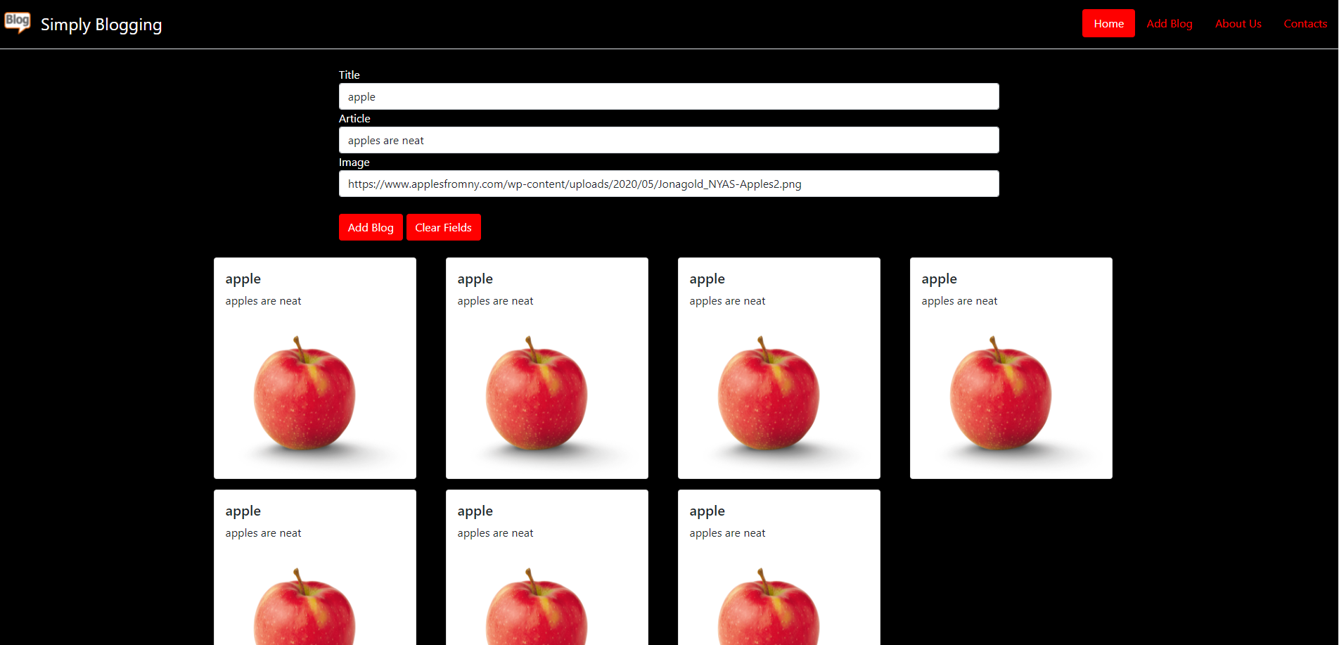

The files for this project will be in the GitHub repository, as well as the source code section of the submission on Simplilearn.